1 Application
LEL8 (electromagnetic), RCCB are applying to the circuit of Ac50/60Hz,230V single phase, 400V three phases , a rated current 16 -100A. and adapted for industrial mining enterprise, trade building, commerce and family. Mainly prevent electric fire and personal casualty accident caused by personal electric shock or leakage of electrified wire netting.本产品符合标准：GB16916.1及IEC61008-1。
Standard Number：GB16916.1,IEC61008-1。

2. Type designation
LE L 8 – 100/ - /
Rated Leakage Operating
Rated current (A)
Poles
Frame level rated current
Design serial number
Function code
CHAC

3 Technical data
Model Versions
Rated voltage(v) : | 230/400V~
Rated current(A) : | 25、32、40、63、80、100
Rated Leakage Operating ln | 0.03、0.1、0.3
lno | 0.5In
Poles : | 2、4
Rated residual making and breaking capacity l m | 1000A
Model Versions
Maximum breaking time of the residual current operating | Mark 2
Mechanical life & Electrical life: | 1000
 | 2000
Pollution | 3
Protection | IP20
Overvoltage | Ⅲ

Mark 2 Maximum breaking time of the residual current operating（s）
Type mA In 2In 5In
Non delay |  | 0.1 | 0.06 | 0.04

4 working and the installing condition.
4.1 : Ambient max temperature is no more than +40℃, minimum temperature is not less than -5℃. No more than +35℃ within 24 hours;
4.2 : altitude is no more than 2000m;
4.3 : when the highest temperature reaches 40℃ the air relative humidity of the installing place can't exceed 50%, We must take measure of the dew in the surface of the product due to the temperature;

5. Overall and mounting dimensions (mm) 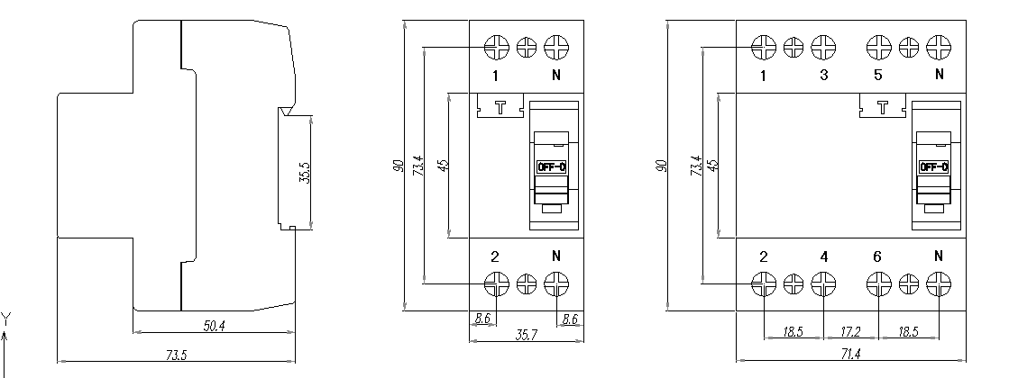
2P 4P

